**Name**: Somatostatin (SOM+) – Amygdala Interneuron

**Biological Data**

**Passive properties**: Vrest = -65.3±4.3 (Karagiannis et al., 2009) Tau =23.6±8.6 (Karagiannis et al., 2009) Rin = 316 (Ma et al., 2006)

________________________________________________________________________________________

**Passive properties of model SOM interneuron:**

|  |
| --- |
| **1. V_rest = -60 mV**  **2. Calculation of time constant:**  Start inject: 300ms / -60.54mV Final Value: -92.21 mV Difference: -32.24 | 63.2% = -20.3771336| -60 - 20.3771336 = -80.3771336 Time at -80.55544: 420.325  τ = 420.325-400  τ = 20.325 ms  **τ = .020325 s**  **3. Input Resistance**  ΔV/ΔI = ( -60 – (-92.2424) )/( 0 – (-100) )  = 32.2423mV / 100pA   = .0322423 V/.0000000001 A = Ω  **R_in = 322.423 MΩ** |

**Comparison of F-I curves Actual: Green, Model: Black (Fanselow et al., 2008)**

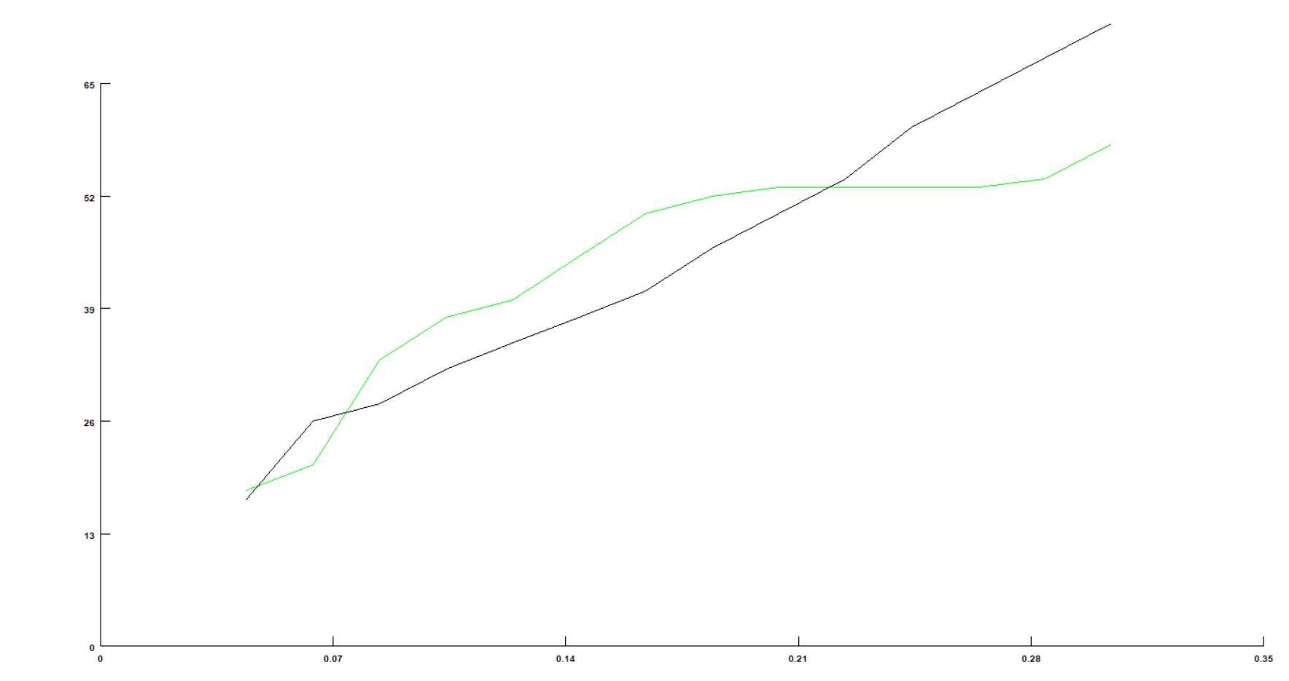

**Match with reported current injection responses:**

|  |  |  |
| --- | --- | --- |
| **300** |  |  |
| **pA** | **Real** | **Cell Model** |

**Table S2. Parameters of single cell models**

|  |  |  |
| --- | --- | --- |
|  | Somatostatin interneuron | |
|  | soma | dendrites |
| Cm (µF/cm2) | 1 | 1.3 |
| Ra (Ωcm) | 150 | 150 |
| Conductance (mho/cm2)  gNabar  gKdrbar  gLeak  gNapbar  gKmbar | 0.08  0.026 $$6.0*{10}^{-5}$$ 0.0014  0.0015 | 0.08  0.026 $$6.0*{10}^{-5}$$ 0.0014  0.0015 |

**References**

Fanselow, E. E., Richardson, K. A., & Connors, B. W. (2008). Selective, state-dependent activation of somatostatin-expressing inhibitory interneurons in mouse neocortex. Journal of Neurophysiology, 100(5), 2640–2652. <https://doi.org/10.1152/jn.90691.2008>

Karagiannis, A., Gallopin, T., Dávid, C., Battaglia, D., Geoffroy, H., Rossier, J., ... Cauli, B. (2009). Classification of NPY-expressing neocortical interneurons. The Journal of Neuroscience, 29(11), 3642–3659. <https://doi.org/10.1523/JNEUROSCI.0058-09.2009>

Ma, Y., Hu, H., Berrebi, A. S., Mathers, P. H., & Agmon, A. (2006). Distinct subtypes of somatostatin-containing neocortical interneurons revealed in transgenic mice. The Journal of Neuroscience, 26(19), 5069 –5082. https://doi.org/10.1523/JNEUROSCI.0661-06.2006